Hi Jarod,

Some of the REST services I designed and deployed for this projects are:

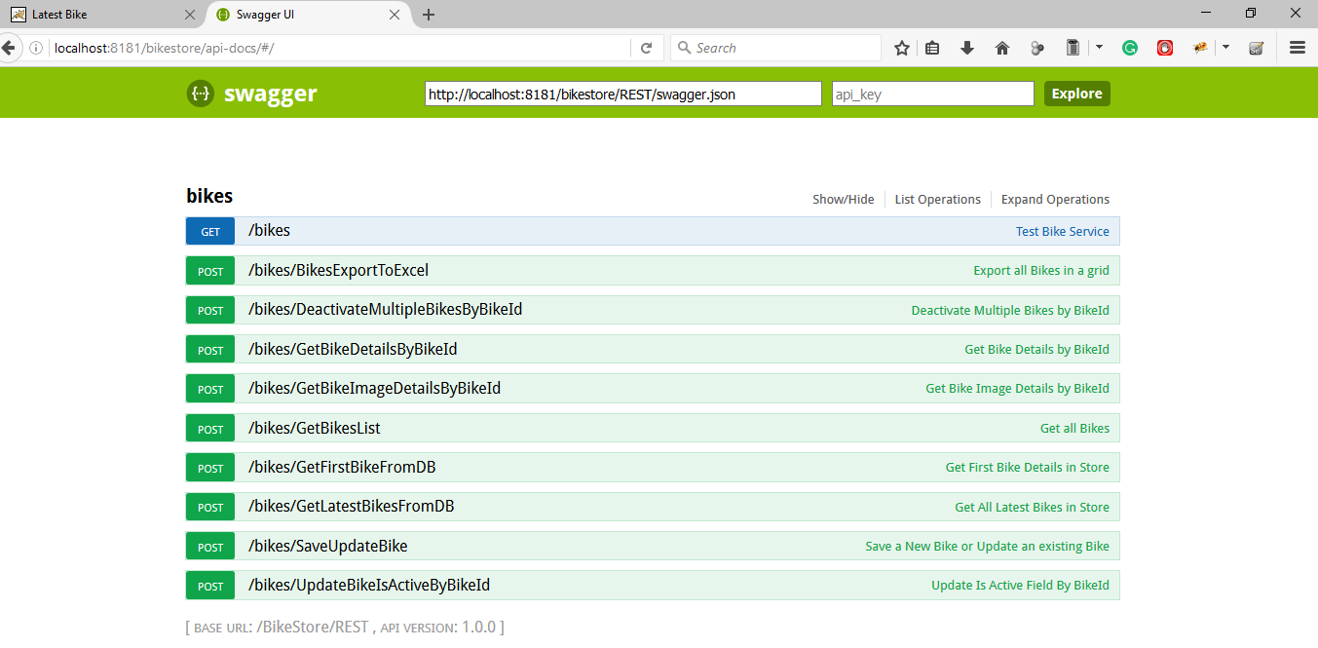

These API are helpful for management i.e. Bike Create, Read, Update, Activate/ Deactivate, Export etc and Client part i.e. Latest bike and Bike Detail Page Binding .

I have completed and tested the Management Part which looks like:

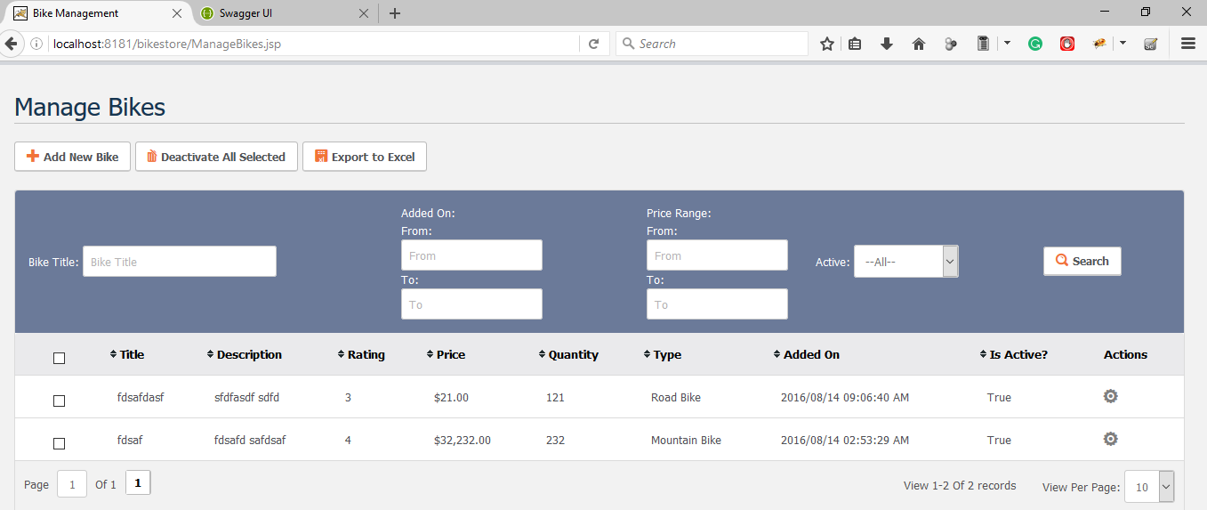

For Action per Bike :

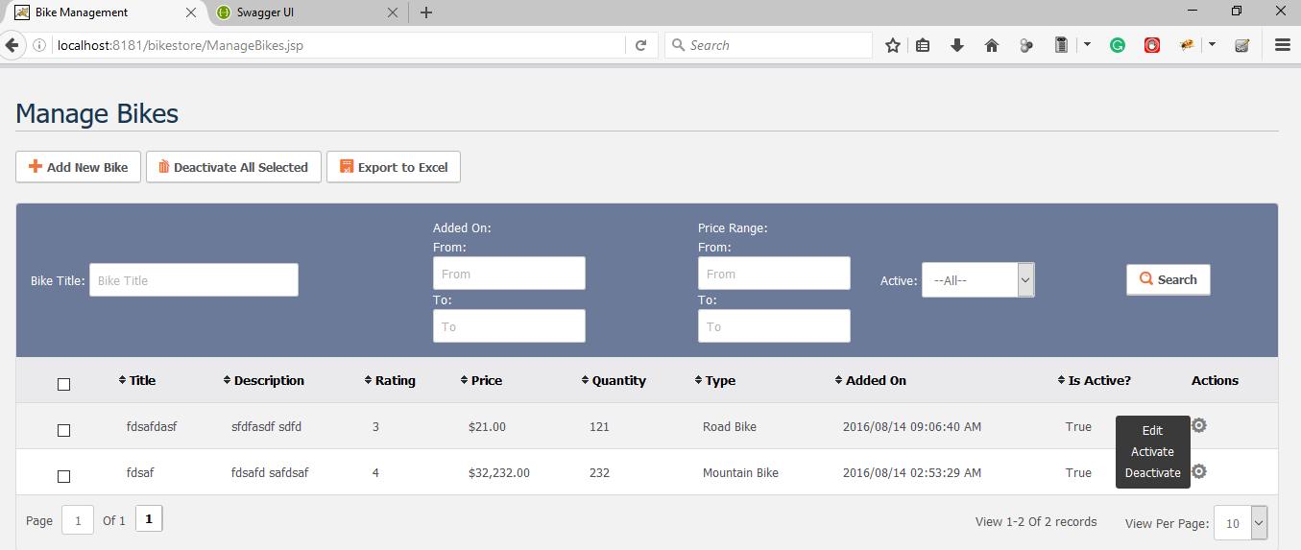

1. Editing a Bike looks:

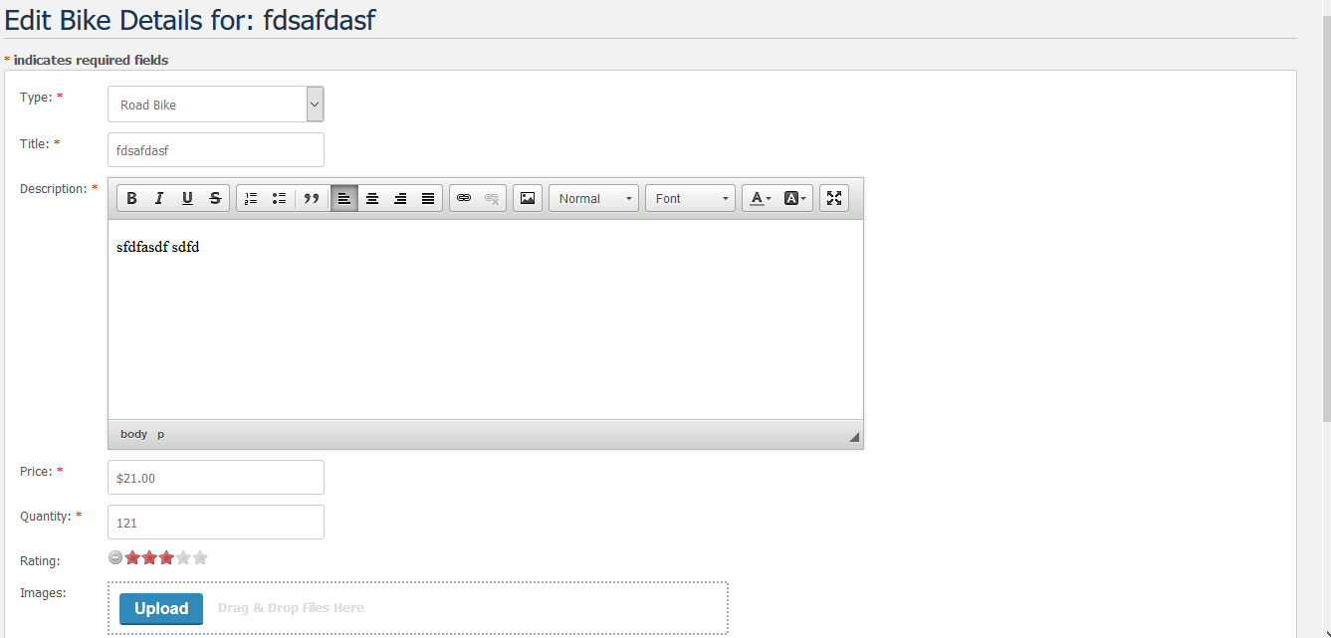



This includes

1. CkEditor for description
2. Star Rating
3. Multiple Image Uploader

I spend long time on Management part so due to time constraint I left the Client part.

For Client Part I was planning to have 2 pages:

1. Latest Bike Page: which binds all bikes in a jQuery Slider: I already have that service to load all latest Bikes just left is binding and designing I a good layout.
2. Item Detail Page: This is similar to Management Edit part where I can bind Bike details based on BikeId.

The JSON Data for Client looks this:



Thank you,

Milson